**AFTER MIDTERM**

Gamma Distribution (Continuous)

When a certain procedure consists of $α$ independent steps, and each step takes Exponential ($λ$) amount of time, then the total time has Gamma distribution with parameters $α$ and $λ$.

Thus, Gamma distribution can be widely used for the total time of a multistage scheme, for example, related to downloading or installing a number of files.

In a process of rare events, with Exponential times between any 2 consecutive events, the time of the $α$-th event has Gamma distribution because it consists of $α$ independent Exponential times.

Example:

We are waiting for 6 consecutive events.

$λ$ is related with frequency most of the time.

is gamma function.

Notice 2 important special cases of a Gamma distribution:

1. When $α$ = 1, the Gamma distribution becomes Exponential. This can be seen comparing (4.7) and (4.1) for $α$ = 1. $Γ$ (1) = 1.
2. Another special case with $λ$ = 1/2 and any $α$ > 0 results in a so-called Chi-square distribution with (2 $α$) degrees of freedom, which we discuss in section 9.5.1 and use a lot in chapter 10.
   1. We haven’t seen chi-square yet.

Exponential distribution is special case of gamma distribution.

Gamma function:

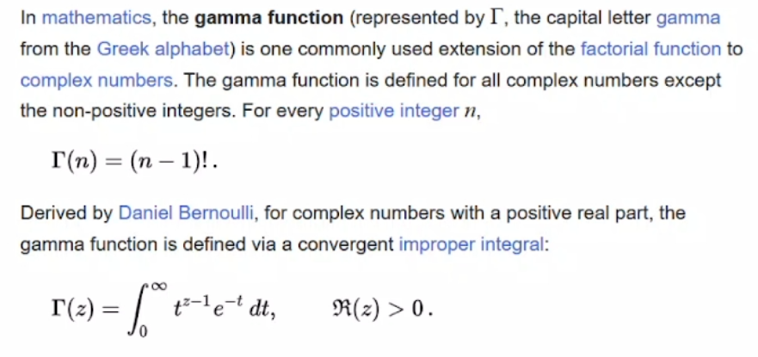



One boundary as infinity makes integral improper.

> 1 -------> asymptotically goes to infinity and gets closer to 0

$α$ < 1 and $α$ = 1 are the inverse functions of the each other. One goes to infinity when x goes to infinity, other one goes to infinity when f(x) goes to infinity.

***Expectation, Variance, and some useful integration remarks:***

There is TABLE for gamma function for $α$ too.

We were accumulating values in cdf. It was non-decreasing function.

$\int_{0}^{∞}{f\left(x\right)dx}$------> from properties of distribution function.

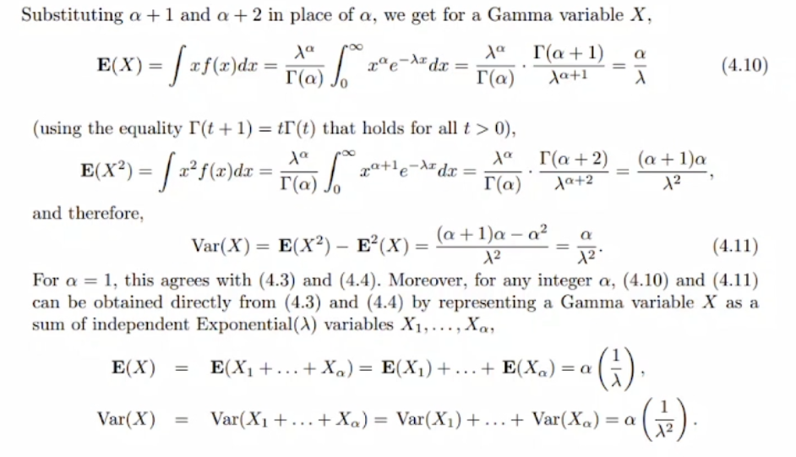



E(X) = /

E(X2) = (/2

Var(X) = / 2

Example:

Something happens sequentially. One happens and another happens. It seems like gamma distribution.

Each block takes exponential time. 🡪 It sounds just like gamma distribution bc we are talking about time which is exponential.

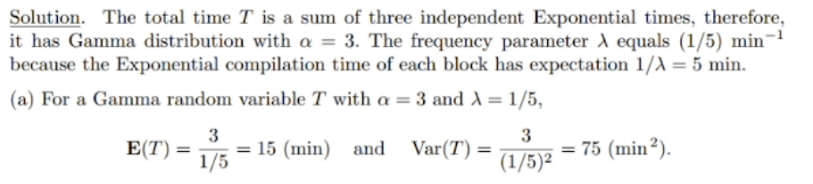

# of consecutive events = $α$ = 3

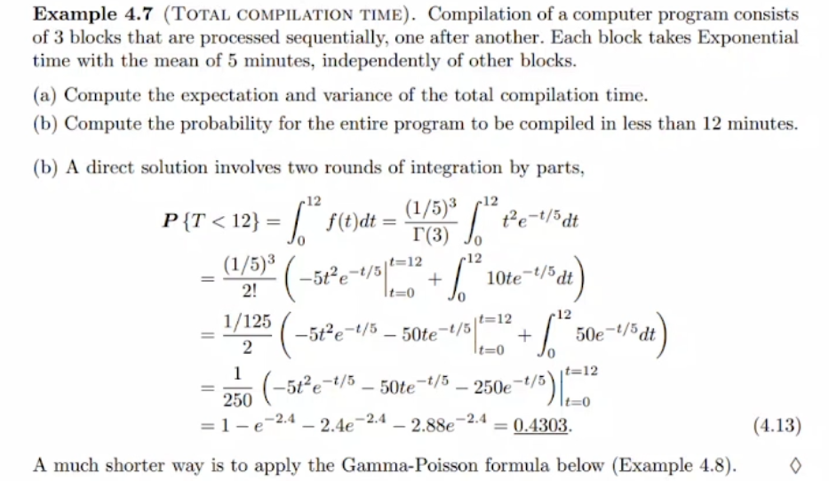

Gamma-Poisson Formula



Time between 2 consecutive rare events is continuous but sometimes you can be interested in the # of events. If you change the variable in correct way, then you can use both approaches. It can be discrete or it can be continuous.

Computation with discrete distributions is easier.

Example:

Number of events has to be done for entire program to be compiled.

We use 2.4 in table.

Example:

Normal Distribution

These ones are bell curves.

Area under the curve is always 1 bc of probability.

If $μ$ = 0, highest point on curve will be on y axis.

Mean gives you where all the values are accumulated around.

Line without dash is standard normal distribution.

* Remember standardization in uniform distribution where we push rectangle between 0 and 1 and height was changing. Here, we do same thing with different shape.



130 people in this class. Assume age of those people is dot in the graph. When you look at the picture, it is mostly very close to being a normal distribution. People are around average age, less people will be so young or so old.

Perfect match with theory and real life.

Expected value and variance are collected using the data. Aftewr using the data, we can graph the distribution function.

***Standard Normal Distribution***

When it is standard, you can find the area using just 1 table. You don’t have to go through different and .

Change variables and use 1 standard table 🡪 this is what we want.

Change X to standard Z (standard normal distribution variable).

Z = X for $μ$ = 0 and $σ$ = 1.

Example:

P{Z < -1.35} = P{Z > 1.35} = 1 – $ϕ$ (1.35)

We are in standard version, mean is 0. If your distance is same to the 0 (to the mean), then your probability is same. This is another advantage of standard normal distribution.

Example:

Standard deviation is how far you are from the mean.

If you don’t use standard normal distribution, you can’t use table so you have to do integrals.

Example:

food stamp 🡪 you can go and buy certain stuffs with that, food help

Inverse of the $ϕ$ is the identity (what is written inside).